Software Requirement Specification Document
For
Digital Consent Management System

Table of Contents
Page Numbers
- Introduction 3-4
  - Purpose
  - Intended Customers/Users
  - Product Scope
  - Outline of the document
- Overall Description 4-6
  - Product Perspective
  - Product Functions
  - User Classes
  - Design and Implementation Constraints
- Diagrams 6-36
  - UML Diagrams
  - ER Diagrams
  - DFD Diagrams
- External Interface Requirements/Screenshots 36-39
  - User Interfaces
  - Hardware Interfaces
  - Software Interfaces
  - Communication Interfaces
- Other Non-Functional Requirements 39-41
  - Performance Requirements
  - Safety Requirements
  - Security Requirements
  - Software Quality Attributes
  - Business Policies/Rules (if any)
- Testing 41-55
  - White-Box Testing
  - Black-Box Testing
- Conclusion 56
- References 56
- Acknowledgements 57

Introduction
- In this modern world , Companies have been collecting and using personal data of customers. User consent must be required for the proper utilization of such data.
- Non digital consent procedures like paper-work or oral consent are not sufficient,unsafe and not easy to trace.
- DCMS is a computer based system which enables the user to digitally give,view and withdraw consent.
- This system will provide a secure and user-friendly digital consent management system.

1.1 Purpose
The purpose of the Digital Consent Management System applies to creating a safe, transparent, and usercontrolled platform for the collection and storage of the digital consent related to the use of data.
- Users can provide consent online instead of filling out paperwork.
- Provide access to view, edit, or revoke consent at any time.
- Assists organizations in legally and ethically utilizing user data.
- Maintain a central and secure record of all consent actions.
- This system enhances trust between users and organizations because it ensures that all personal information is processed only with explicit and consensual agreement.

1.2 Intended Customers / Users
Target users for this system will include:
- End Users-Customers
  - General Internet Users
  - Healthcare Users
  - Students
  - Employees/Job Seekers
  - Banking and Financial Service Users
  - Government Service Users
- Organizations
  - Hospitals
  - Banks
  - Educational Institutions
  - IT companies
  - Government departments

1.3 Product Scope
- The Digital Consent Management System has the following scope:
  - User registration and authentication
  - Digital Consent form generation
  - Public acceptance or rejection of consensual behaviour
  - Withdrawal of consent
  - Storage of consent information securely
  - Audit trail for all consent activities
  - Admin Dashboard for Monitoring

- Out of Scope:
  - Legal dispute resolution
  - Integrating third-party analytics capabilities

1.4 Outline of the Document

The report consists of the following pages:
- Section 1: Introduction and purpose of the System
- Section 2: General description of the product
- Section 3: Diagrams (UML,ER,DFD)
- Section 4: External Interface Requirements/Screenshots
- Section 5: Non-Functional Requirements
- Section 6:Testing
- Section 7: Conclusion
- Section 8: References
- Section 9: Acknowledgements

2. General Description

The Digital Consent Management System is an application for either a web application or a mobile application that helps in digital user consent management. It eliminates manual consent mechanisms with a transparent and secure digital approach.

2.1 Product Perspective

The Digital Consent Management System is modeled on a contemporary computer program,which could be integrated with the current electronic infrastructure and could also be a separate entity.Here are some indications of the general position of the product.
- System Type
  - The system is a self-contained application used for the handling digital consent.
  - It can run alone without depending upon any other software.
  - It is also made for integration with other systems if the need arises.
- Architecture Perspective • It uses a client-server model.
  - The users are able to interact with the system through the web interface or the mobile interface.
  - The backend manages:
  - Fourier transform
  - Consent Processing
  - Screening/Security checks.
In the centralized database,the following information is stored:
  - User details
  - Consent records
  - Audit Logs
- Integration
The process can be integrated with:
- Hospital Management Systems
- Banking platforms
- Government portals
- Social structures
- The integration can be achieved through APIs
- This will enable organizations to reuse the consent system across various services.
Additional functionalities can be added without affecting the existing system:
- Mobile Apps
- Advanced analytics
- Multilingual support

2.2 Product Functions

➢ The primary operations performed by this system are:
- User login and authentication
- Showing requests for consent
- Accepting or rejecting consent
- Accessing consent history
- Withdrawing consent
- Establishment and maintenance of administration for consent forms ensuring secure data storage and retrieval
- Notification alerts for consent updates

2.3 User Classes and Characteristics

- End Users (Data Owners)
  - Non-technical users, privacy-conscious, access the systembvia web or mobile devices.
  - Can give ,view,modify,and withdraw consent; can view consent history.
  - Cannot access other users data or system settings.
- Organizations
  - Employees with moderate technical knowledge are responsible for legal data handling.
  - Can create consent requests,view consent status,and generate reports.
  - Cannot access personal data without consent or use data after consent withdrawal.

2.4 Design and Implementation Constraints

The design and implementation of the Digital Consent Management System is affected by various technical,legal, and operational constraints.These constraints must be kept in mind for successful implementation and proper functioning of the system.
.
- Technical Constraints
    - The system needs to be compatible with widely used browsers and mobile phones.
    - It must be able to perform well on less powerful hardware.
    - Internet connectivity is essential for the management of consent.
    - The system needs to rely on common and trusted technology.
    - Database size and performance have to balance as user data expands.
- Security Constraints
    - User authentication should be robust in order to avoid unauthorised access.
    - The sensitive data has to be safeguarded through encryption.
    - The need for protection against common threats such as data leakage also arises.
- Legal and Compliance Constraints
    - The system has to support with data protection/privacy legislation.
    - Consent must be express,fully informed,and freely revocable.
    - The records of consent must be maintained for purposes of verification.
- Time and Budget Constraints
    - Work on the project should be done with the timeframe provided.
    - Development has to be carried out using cost-effective or open source tools.
    - Availability of advanced functions could be impacted by limited manpower and resource availability.
    - Focus on the essential functions, instead of the enhancements.

3.Diagrams:

3.1 UML Diagrams

- Use-case Diagrams:

Module1:
Consent Collection

Description:

When a user registers or uses a service, this module shows what data will be collected and what is the purpose of the data. The User can agree or disagree. If the user agrees, the system stores the consent safely.
Primary Actors:

User, Registered user, Guest user
Secondary Actors:

Data Fiduciary, Consent management system

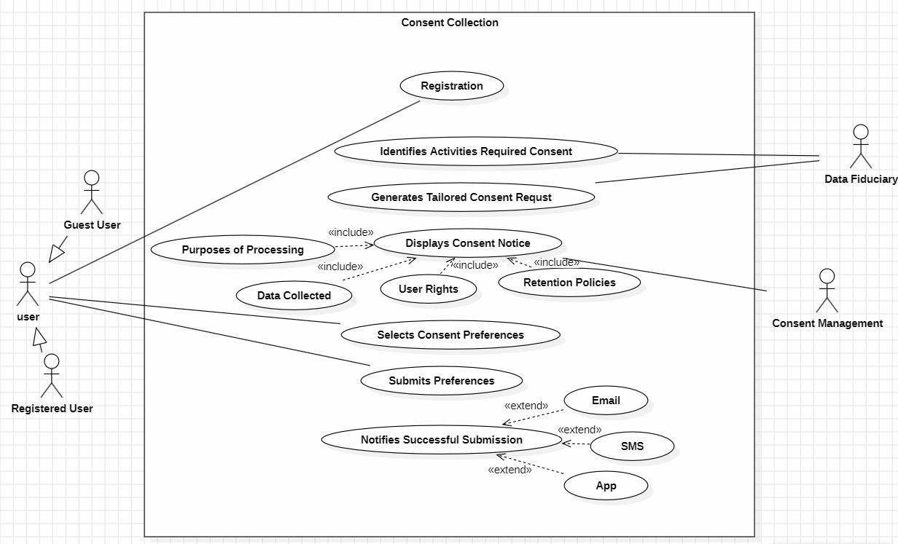
Module-2:
Consent Validation
Description:

This module checks whether the given consent is valid or not. Before using a user’s data, the system verifies if consent exists, if it is still active, and if it matches the requested purpose. Only valid consent allows data processing.
Primary Actors:

User, Registered user, Guest user
Secondary Actors:

Data Fiduciary, Consent management system

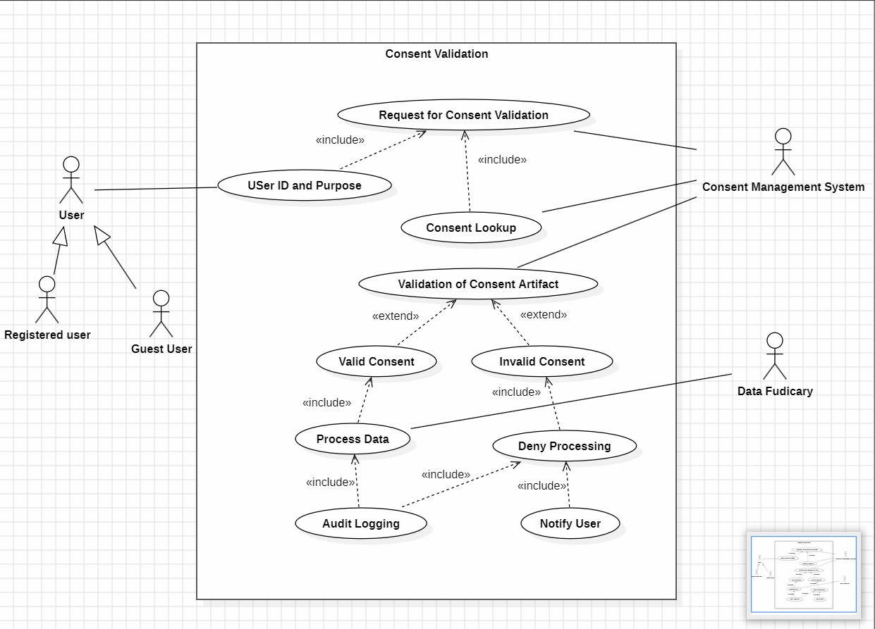
Module-3:
Consent Update
Description:

This module allows the user to change their consent choices. The user can add new permissions, remove existing ones, or modify how their data is used. After updating, the system saves the new consent details and keeps a record of the changes.

Primary Actors:
Registered user
Secondary Actors:

Data Fiduciary, Consent management system

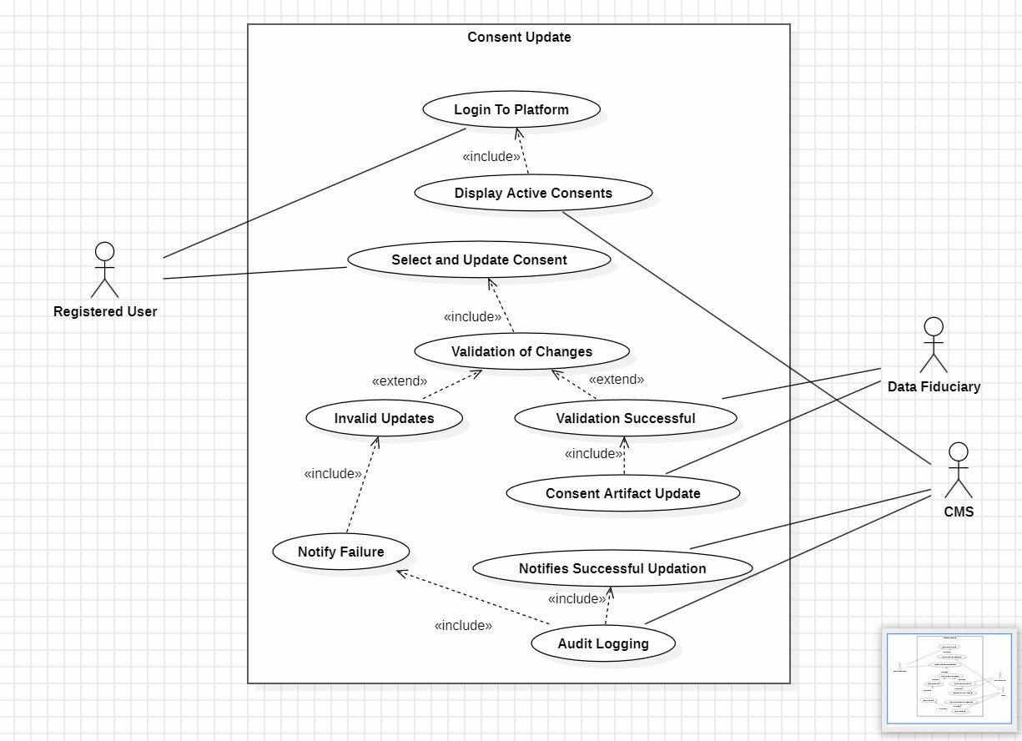
Module-4:
Consent Renewal
Description:

This module is used when consent is about to expire. The system informs the user that their consent needs to be renewed. The user can renew the terms again and give fresh consent. If renewed the system updates the validity period.
Primary Actors:
Registered user
Secondary Actors:

Data Fiduciary, Consent management system

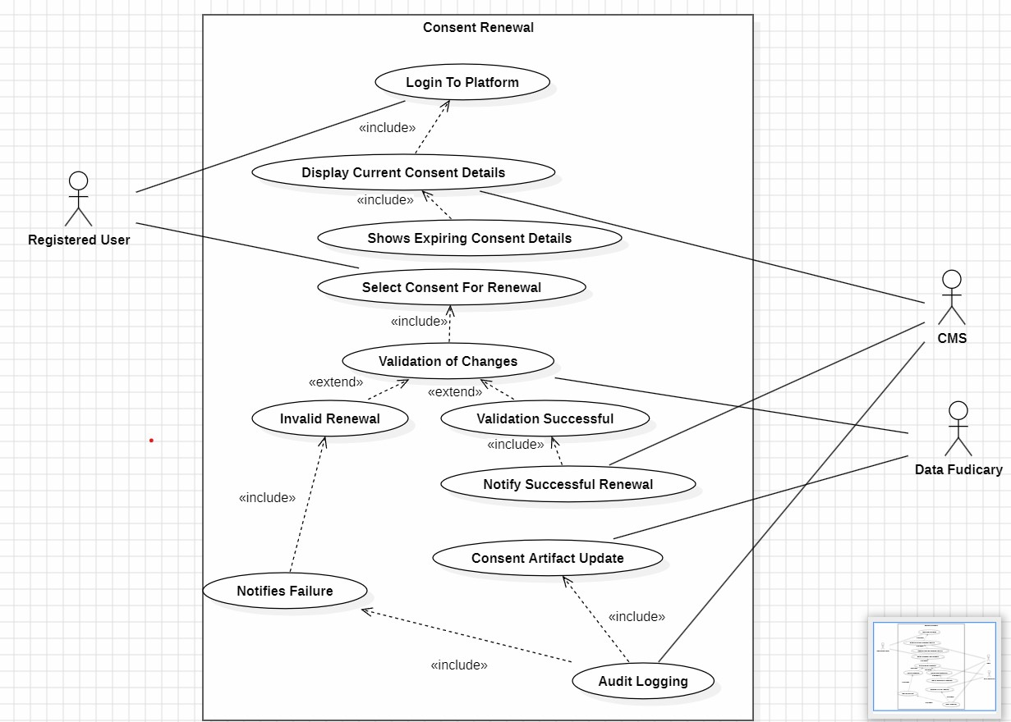
Module-5:
Consent Withdrawal
Description:

This module allows the user to with draw their consent at any time. When the user withdraws the consent, the system stops using their data for that purpose. The system also updates records and may notify related parties to stop data processing
Primary Actors:

Registered User, Third party User
Secondary Actors:

Data Fiduciary, Consent management system

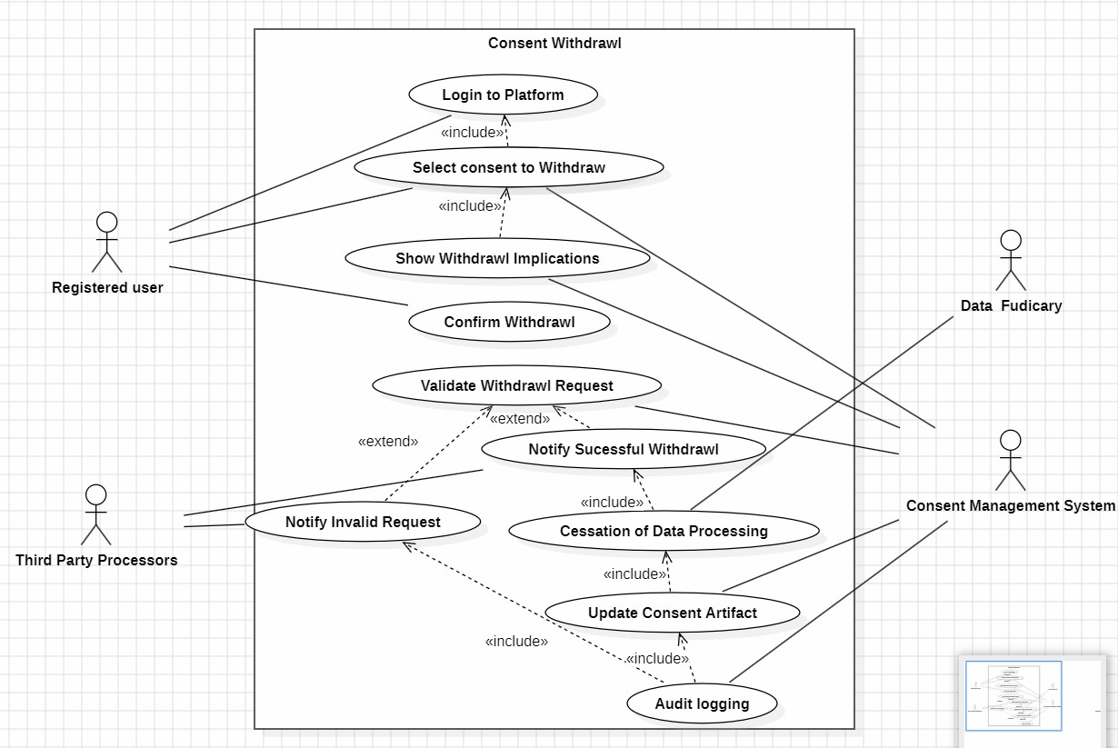
b) Class Diagrams:
Module-1:
Consent Collection
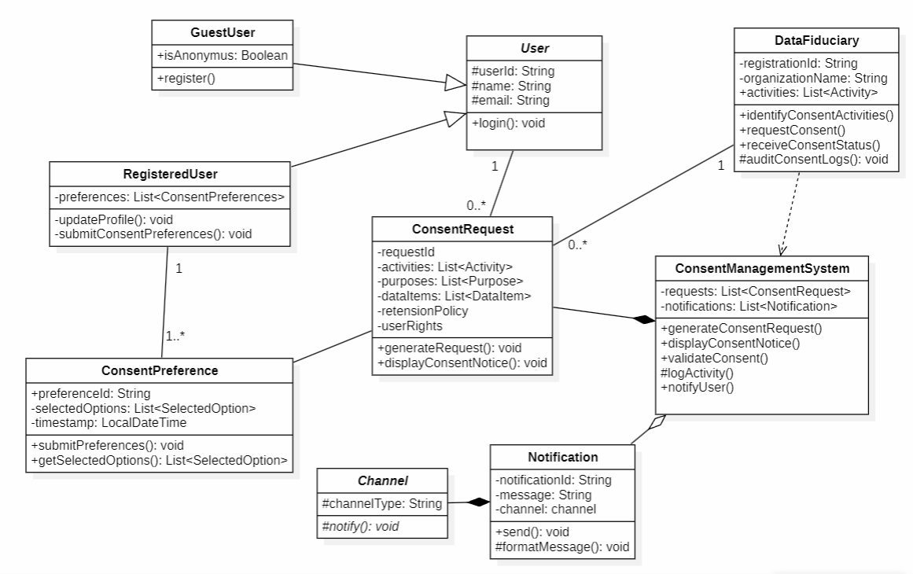
Module-2:
Consent Validation
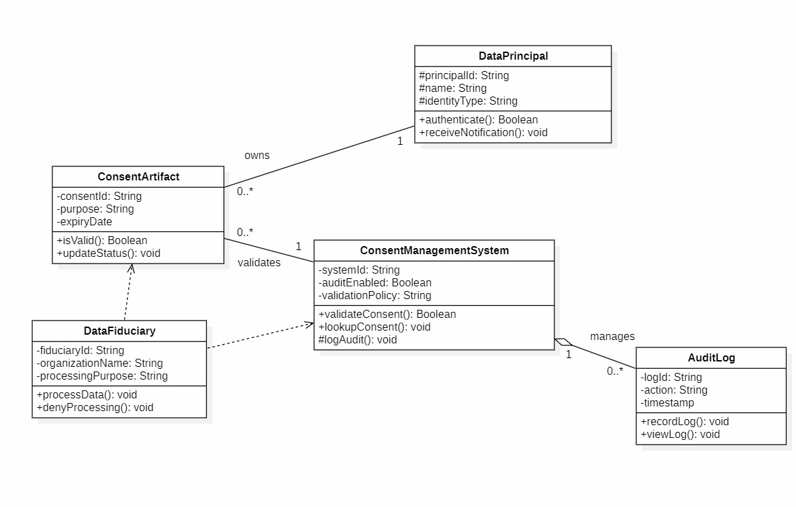

Module-3:
Consent Update
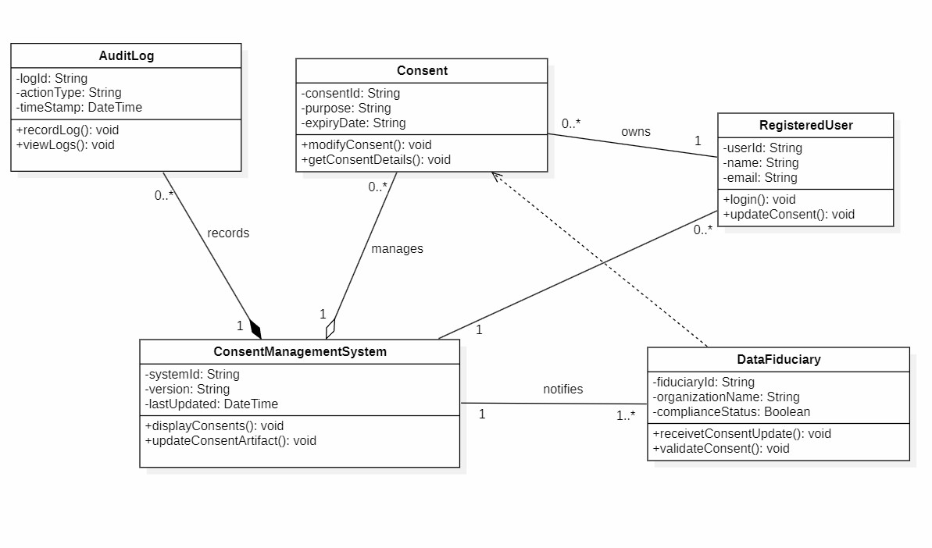

Module-4:
Consent Renewal
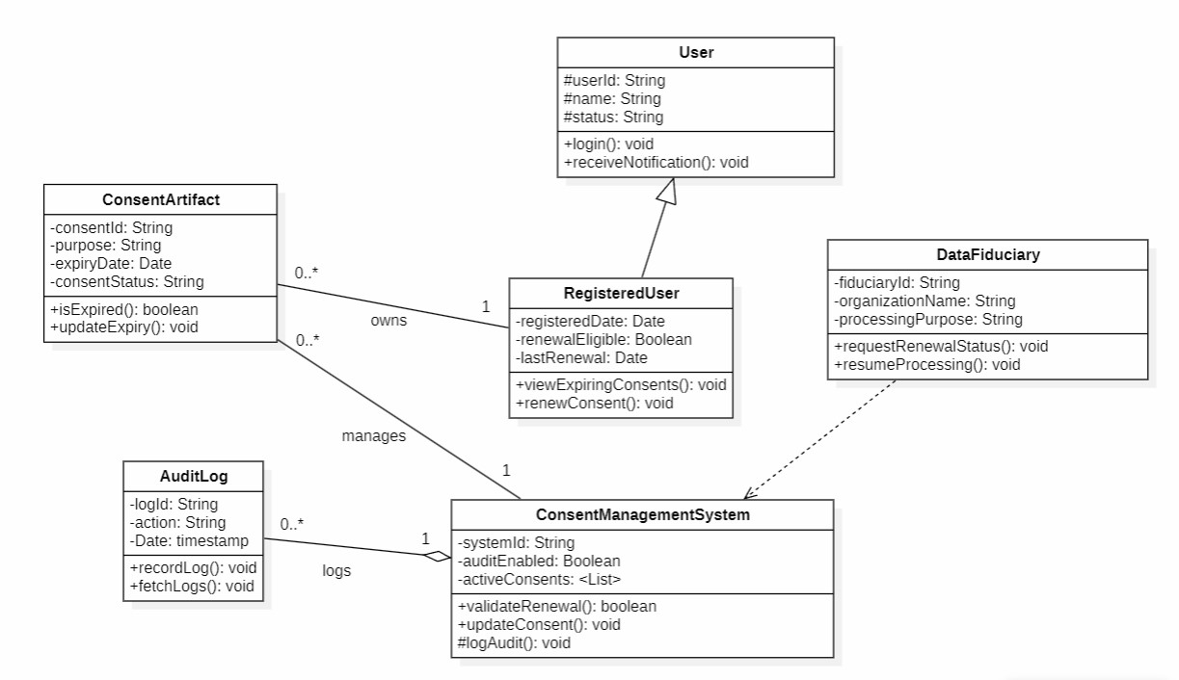

Module-5:
Consent Withdrawal

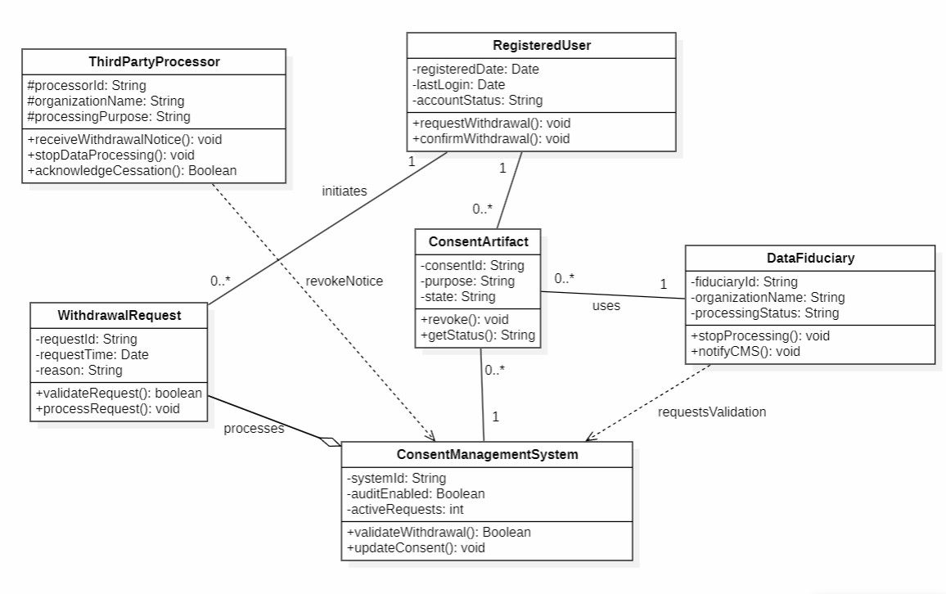
- State chart Diagrams:
Module-3: Consent Update
Registered User Class:

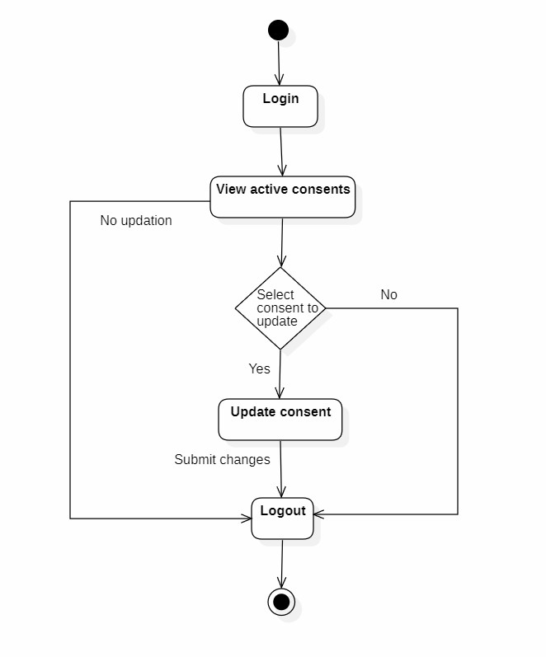

Consent Class:

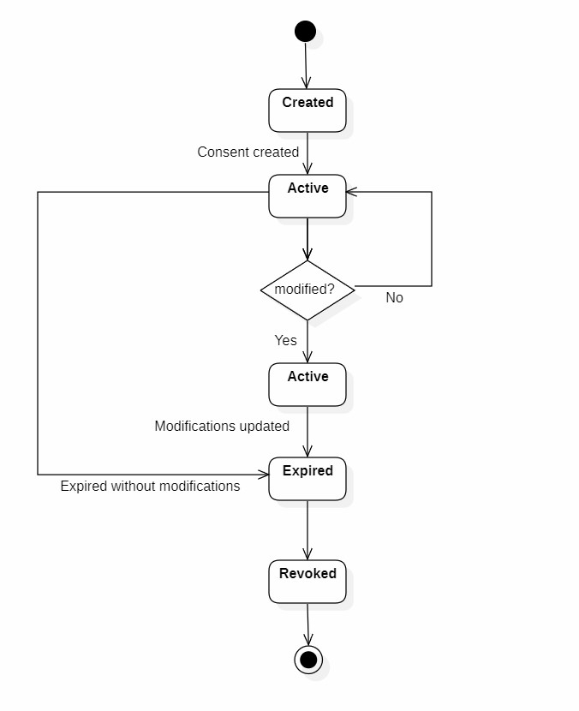

Consent Management Class:

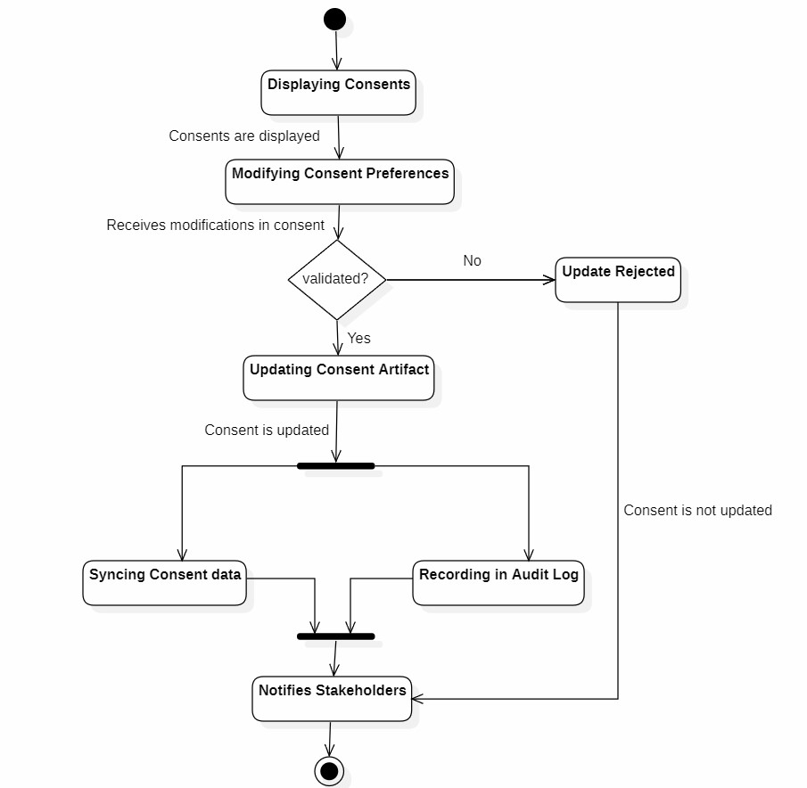

Audit Log Class:

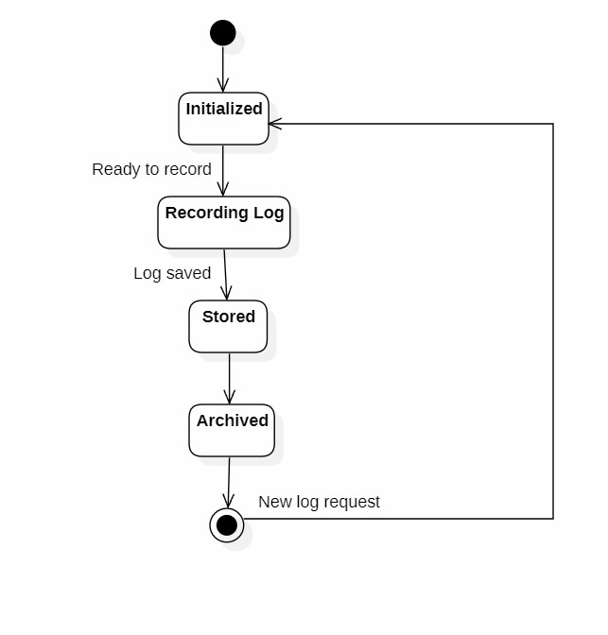

Data Fiduciary:

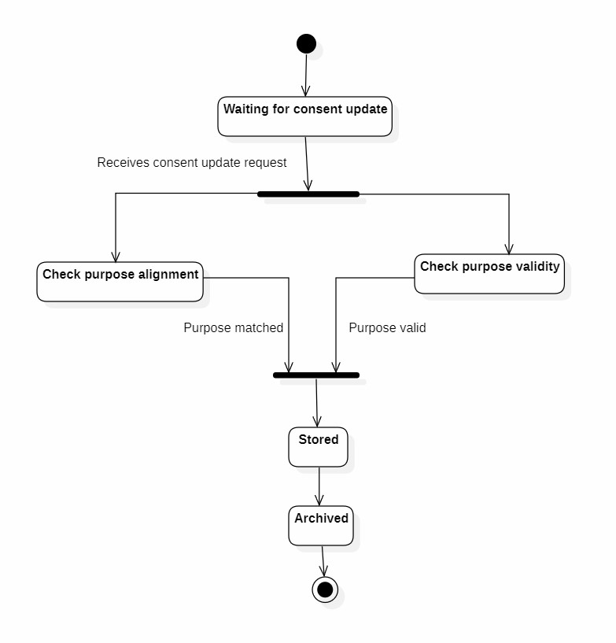

- Activity Diagrams:

Module-1: Consent Collection

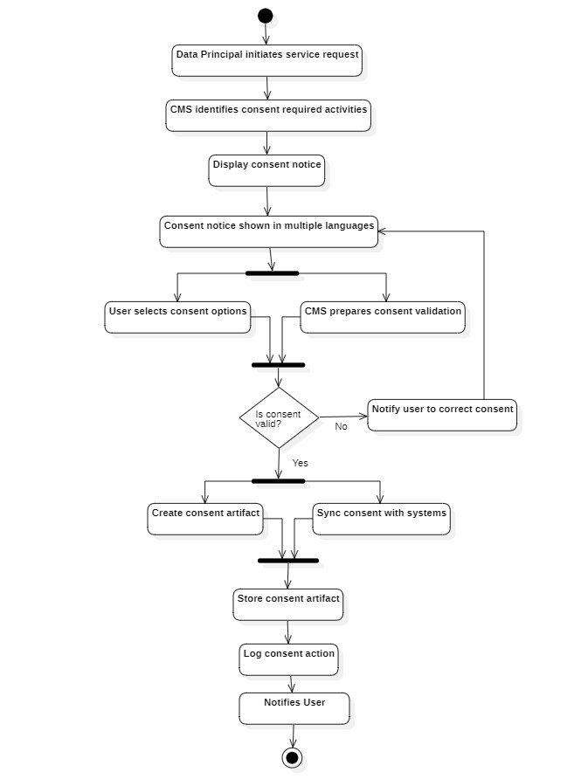

Module-5: Consent Withdrawal

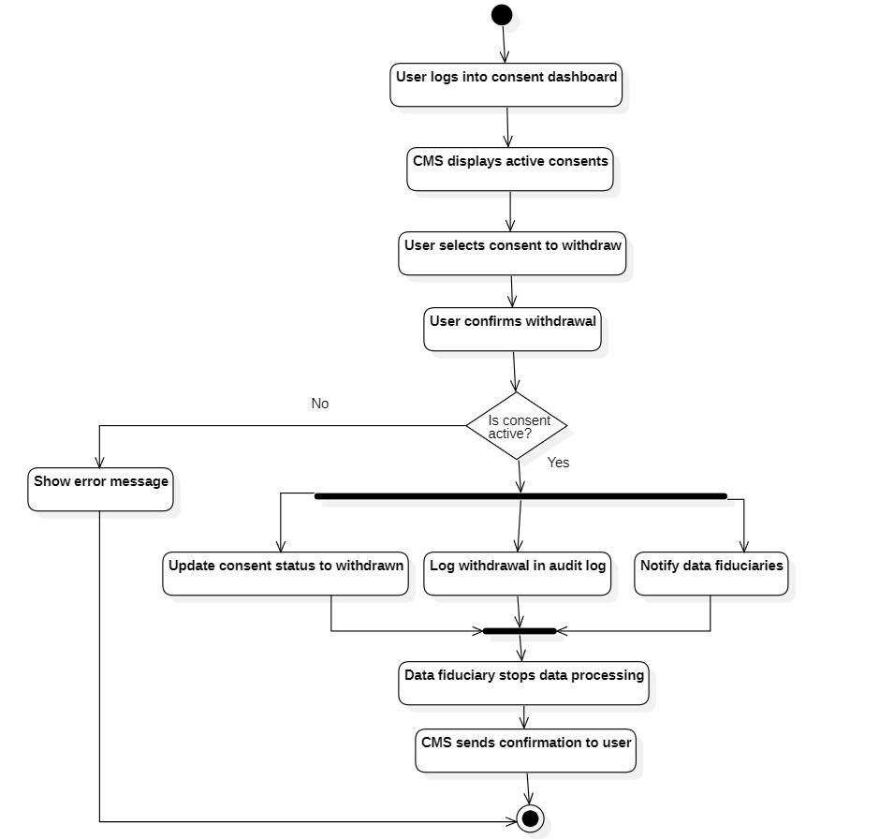

- Sequence Diagrams:

Module-1:
Consent Collection

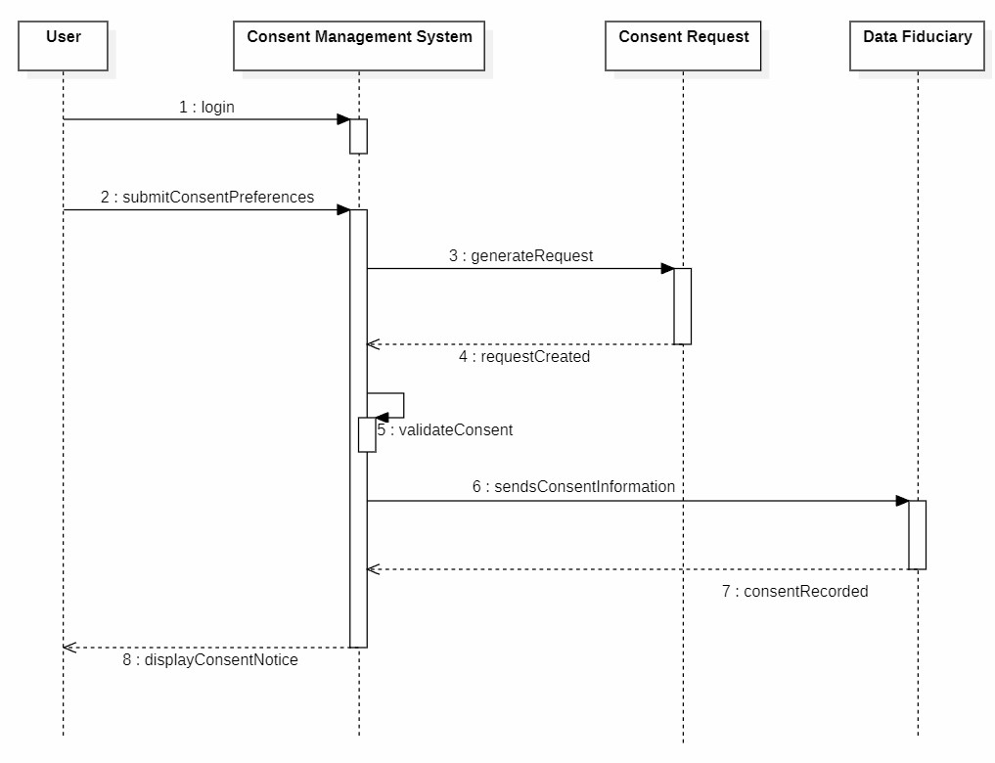

Module-2:
Consent Validation

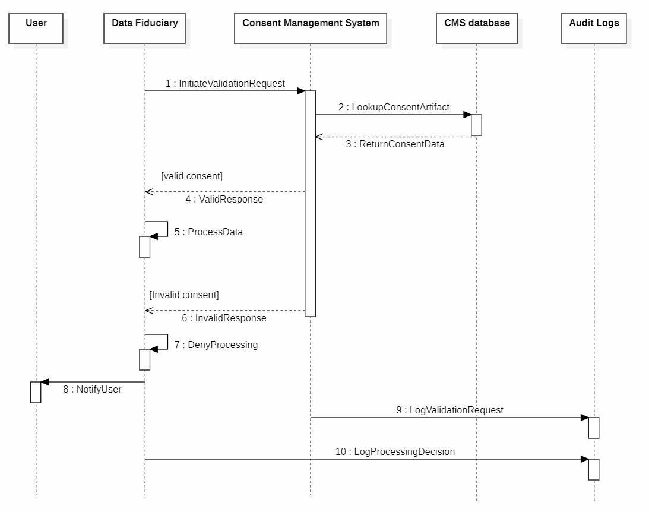

Module-3:
Consent Update

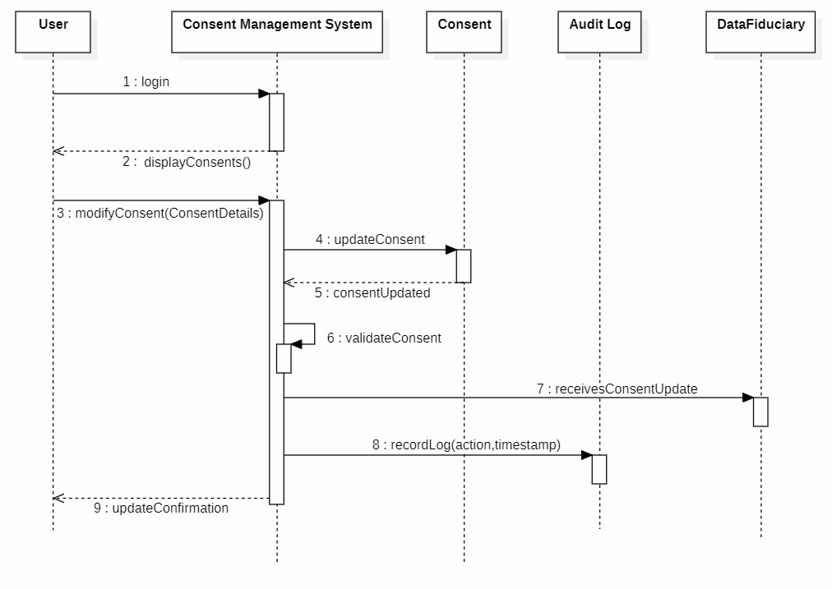

Module-4:
Consent Renewal

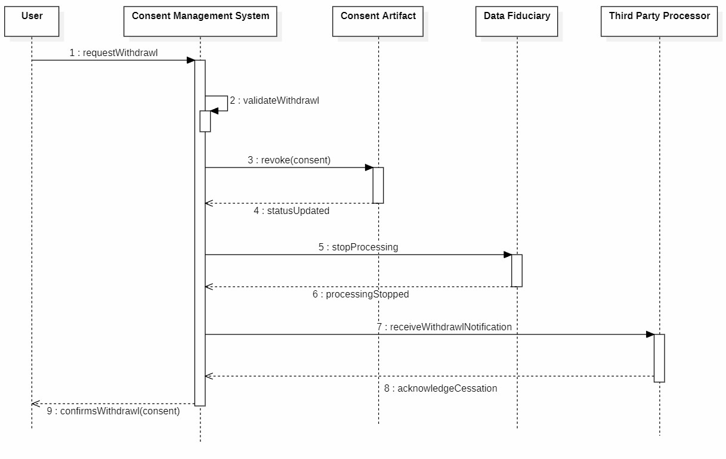

Module-5:
Consent Withdrawal

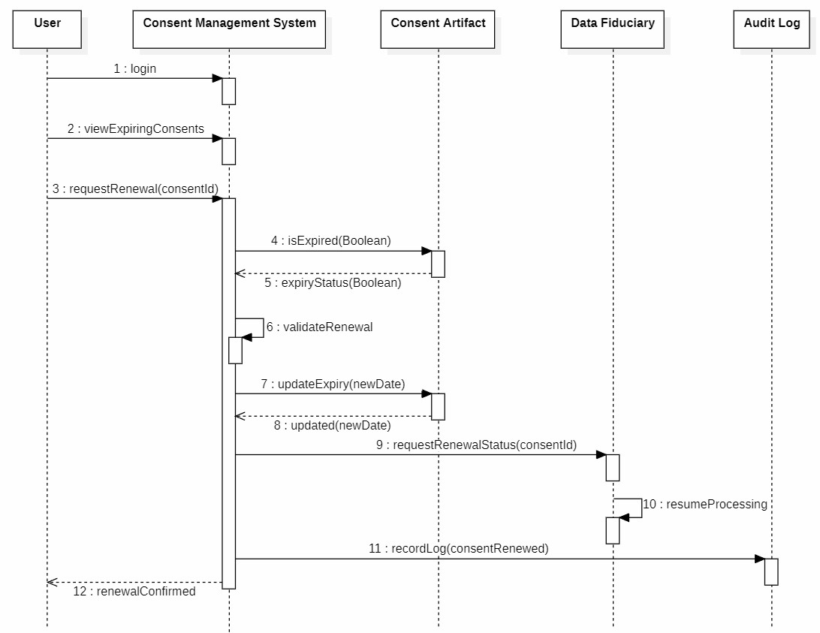

- Collaboration Diagrams:

Module-1:
Consent Collection

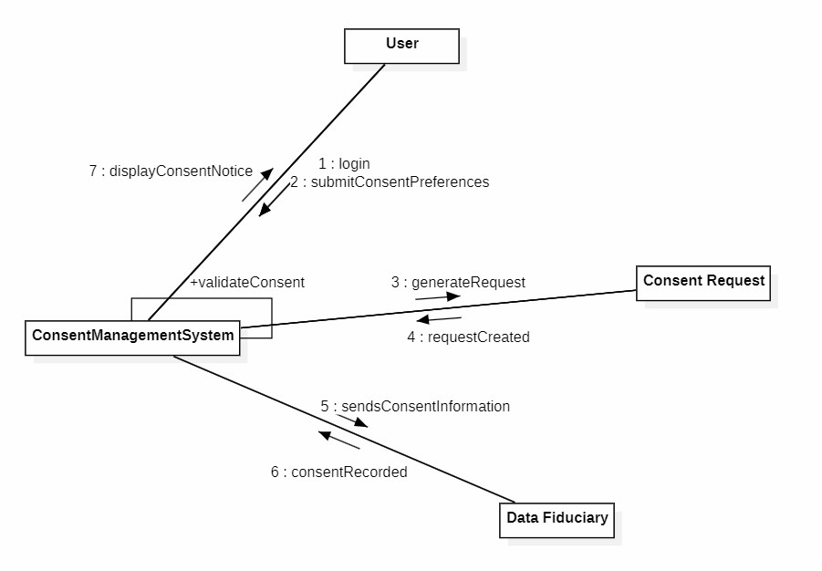

Module-2:
Consent Validation

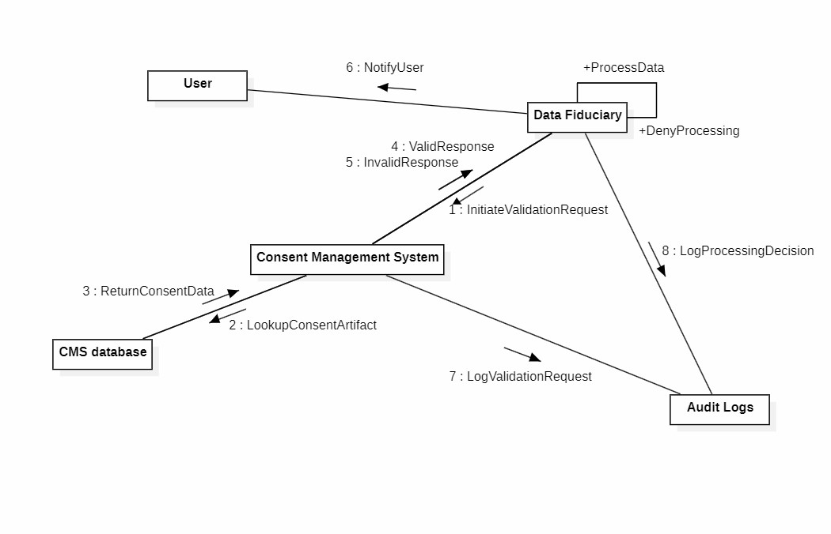

Module-3:
Consent Update

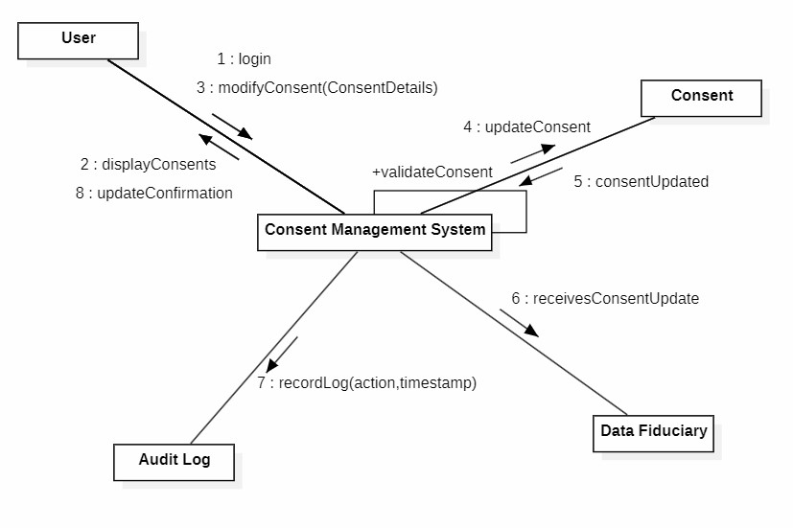

Module-4:
Consent Renewal

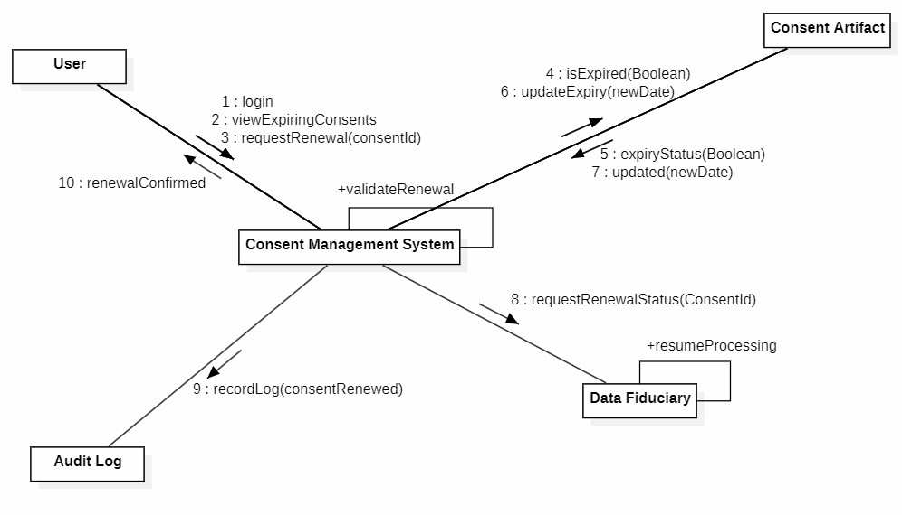

Module-5:
Consent Withdrawal

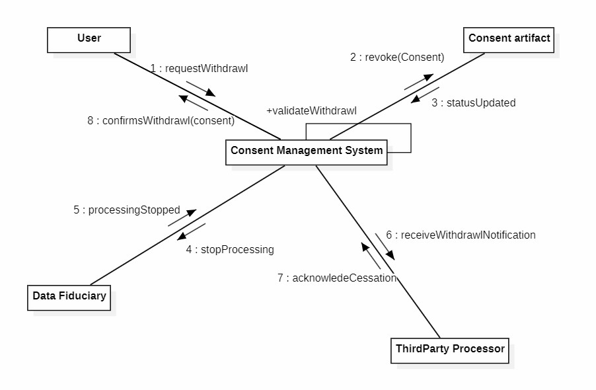

3.2 ER Diagram

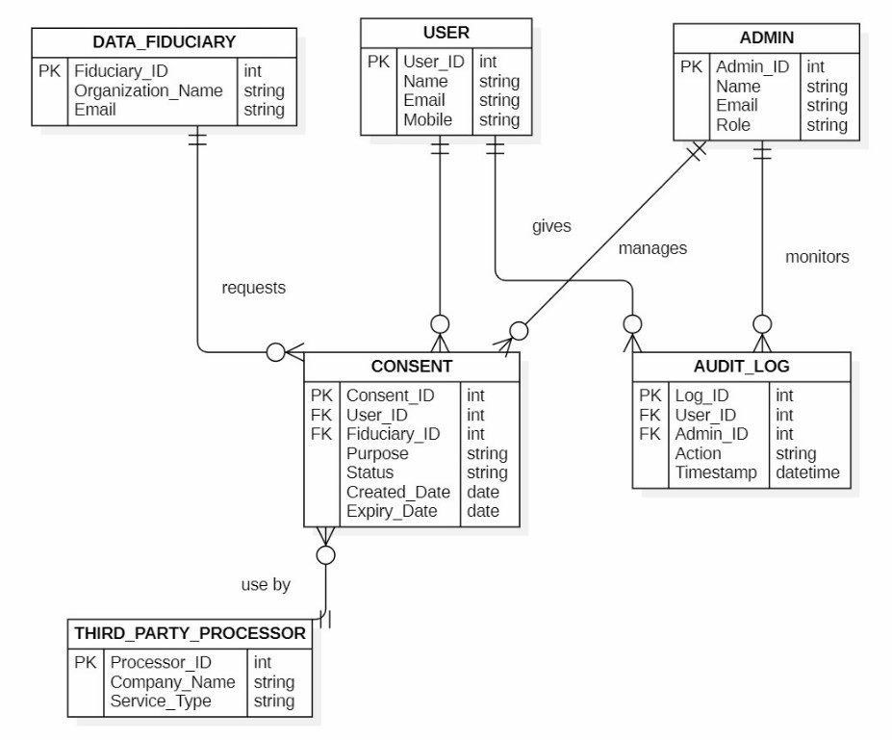

3.3 Data Flow Diagrams

DFD - Level 0

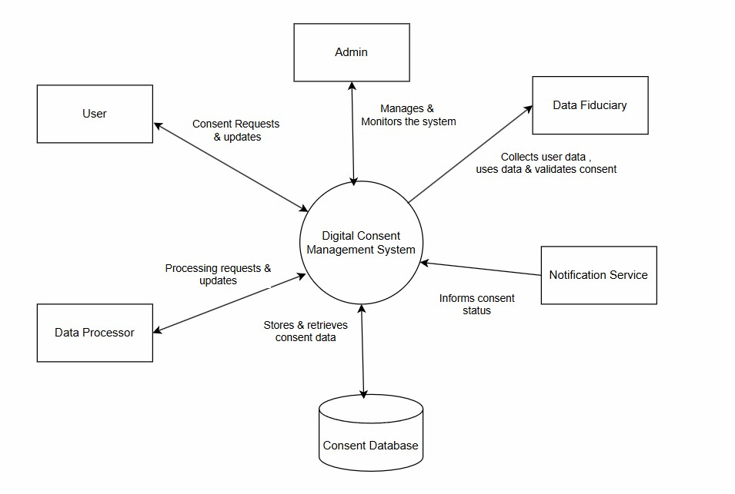

DFD - Level 1

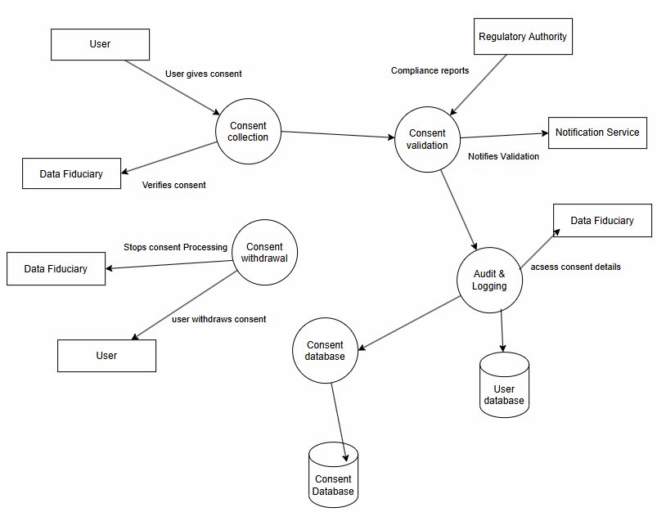

4.External Interface Requirements/Screenshots

4.1 User Interfaces
- User Interface: It allows users to register, login, give, update, renew, and withdraw consent and view consent history.
- Data Fiduciary Interface: It allows organisations to validate user consent, monitor consent status, and generate compliance reports.
- Administrator Interface: It allows administrators to manage users ,assign roles and permissions, configure policies, and monitor system activities.
- Notification Interface: It allows the system to display alerts , remainders and updates through email,SMS, and in app messages.

4.2 Hardware Interfaces
- The DCMS does not require specialized hardware devices.
- Additional hardware like biometric devices or sensors is optional and may be used only for enhanced security features.

4.3 Software Interfaces
- Operating Systems
The DCMS is compatibale with multiple operating systems to ensure wide accessibility.
    - Windows and linux for server hosting.
    - Windows ,macOS ,and Linux for desktop users.
    - Android and iOS for mobile users.
- Database Management Systems
The system interacts with the database to store and manage the data securely. The database stores user details, consent records, audit logs, and system Configurations.
    - MYSQL/PostgreSQL for relational data storage.
    - MongoDB for document based data.
    - Backup and recovery software for data protection.
- Application Programming Interfaces
APIs enable integration with external systems and services. This intrfaces allow secure communicationbetween different software systems.
      - RESTful APIs for consent validation.
      - APIs for data exchange with fiduciaries and processors.
      - Authentication APIs using OAuth/JWT.
      - Thirdparty integration APIs.
4.4 Communication Interfaces

- Network Protocols
The dcms uses standard network protocols for communication. These protocols ensure reliable and secure data transmission.
    - HTTP/HTTPS for web access.
    - HTTPS with SSL/TLS encryption for secure communication.
    - FTP/SFTP for secure file transfer.
- Data Exchange Formats
The system uses structured formats for data communication.
    - JSON for API-based communication.
    - XML for legacy system integration. • CSV for data export and sharing.
- Notification Communication Channels
The system uses multiple channels for communication. These channels ensure timely delivery of messages.
    - Email using SMTP protocols.
    - SMS using telecom gateway APIs.
    - Push notifications for mobile apps.
    - In-app messaging system.

5.1 Performance Requirements
- The system shall respond to the user requests within 2-3 seconds under normal load.
- Consent validation shall be completed in real time(within 1-2 seconds).
- The system should support multiple concurrent users without delay.
- Dashboard pages shall load within 5 seconds.
- Report generation shall be completed within 5 seconds.

5.2 Safety Requirements
The system shall ensure that user data and operations are protected from accidental loss, damage, or misuse.
- The system shall prevent accidental deletion of consent records.
- Automatic backup mechanisms shall be implemented.
- Data recovery procedures shall be available in case of system failure.
- System updates shall not affect existing data.
- Warning messages shall be displayed before critical operations.
- Fail-safe mechanisms shall be implemented during hardware or software failures.
- User sessions shall be protected from unexpected termination.

5.3 Security Requirements

The CMS shall provide strong security measures to protect data and ensure compliance with legal regulations.
- All data shall be encrypted during transmission and storage.
- Multi-Factor Authentication (MFA) shall be implemented.
- Role-Based Access Control(RBAC) shall restrict unauthorized access.
- Secure login and logout mechanisms shall be provided.
- Protection against cyber-attacks such as SQL Injection, Cross-Site Scripting(XSS), and CSRF attacks.
- Audit logs shall be tamper-proof.
- Automatic session timeout shall be enabled.
- Regular security audits shall be conducted.

5.4 Software Quality Attributes

The CMS shall ensure high software quality for reliable and efficient operations.
- The system shall run on different platforms like web and mobile and can be easily migrated.
- The system shall uses resources effectively and provides fast processing with low memory usage.
- The system should be modular and well documented ,making it easy to update and upgrade.

5.5 Business Policies

The CMS shall follow organizational and legal business policies to ensure regulatory compliance and ethical data handling.
- Consent must be collected only for specific and lawful purposes.
- Users must provide explicit and voluntary consent.
- Consent must be revocable at any time.
- No data processing shall occur without valid consent.
- Consent records must be stored securely for audit purposes.
- Data retention shall follow predefined policies.
- User privacy shall be prioritized at all times.
- Data sharing with third parties shall require prior consent.
- Testing
6.1 White-Box Testing: Module 2: Consent validation
Code:

from datetime import datetime consent_db = {
"U101": {
"P1": {
"status": "Active",
"expiry": "2026-12-31",
"scope": ["name", "aadhaar"]
}
}
}
def consent_validation(user_id, purpose_id, requested_scope, processing_purpose):
if user_id not in consent_db or purpose_id not in consent_db[user_id]:
return "Consent Not Found" consent = consent_db[user_id][purpose_id] if consent["status"] != "Active": return "Consent Not Active" expiry_date = datetime.strptime(consent["expiry"], "%Y-%m-%d") if datetime.now() >expiry_date:
return "Consent Expired" if processing_purpose != purpose_id:
return "Purpose Mismatch" for item in requested_scope: if item not in consent["scope"]: return "Scope Exceeded"
return "Processing Allowed"

Control Flow Graph:

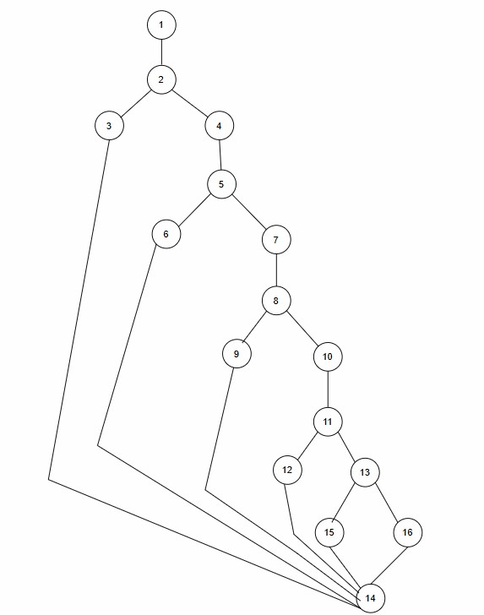
Cyclomatic Complexity:

- Cyclomatic Complexity in Software Testing is a testing metric used for measuring the complexity of a software program.
- Cyclomatic complexity can be calculated by using control flow graphs or with respect to functions, modules, methods or classes within a software program.

➢ Complexity is computed in one of three ways:

Method 1: Using Number of inner Regions + Outer region
Total Regions = 5+1
Cyclomatic Complexity = 6
Method 2:Using Edges and Nodes
V(G)=E−N+2
Here Edges =23 , Nodes = 20
V(G) = 20 – 16 + 2 V(G) = 6
Method 3:Using Decision (Predicate) Nodes
V(G) = P+1
V(G)= 5+1 =6 , Where P = Number of predicate (decision) nodes

3. Independent Program Paths

Path 1 – Consent Not Found 1 → 2 → 3 → 14
Path 2 – Consent Not Active
1 → 2 → 4 → 5 → 6 → 14
Path 3 – Withdrawal Not Initiated by User
1 → 2 → 4 → 5 → 7 → 8 → 9 → 14
Path 4 – Legal Exception
1 → 2 → 4 → 5 → 7 → 8 → 10 → 11 → 12 → 14
Path 5 – Successful Withdrawal
1 → 2 → 4 → 5 → 7 → 8 → 10 → 11 → 13 → 15 → 14
Path 6 –
1 → 2 → 4 → 5 → 7 → 8 → 10 → 11 → 13 → 16 → 14
Design Test Cases:
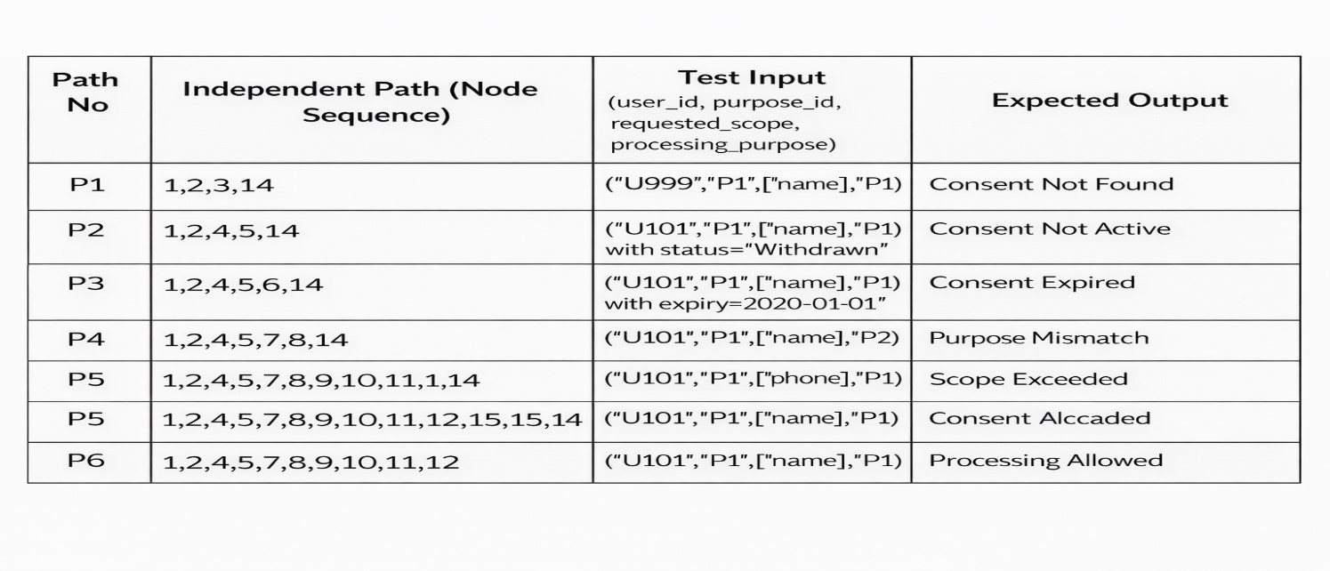
Unit Testing:
import unittest class TestConsentValidation(unittest.TestCase):
def setUp(self):
consent_db["U101"]["P1"]["status"] = "Active" consent_db["U101"]["P1"]["expiry"] = "2026-12-31"
# Test 1 Consent not found def test_consent_not_found(self): result = consent_validation("U999", "P1", ["name"], "P1") self.assertEqual(result, "Consent Not Found")
# Test 2 Consent not active def test_consent_not_active(self): consent_db["U101"]["P1"]["status"] = "Withdrawn" result = consent_validation("U101", "P1", ["name"], "P1") self.assertEqual(result, "Consent Not Active")
# Test 3 Consent expired def test_consent_expired(self): consent_db["U101"]["P1"]["expiry"] = "2020-01-01" result = consent_validation("U101", "P1", ["name"], "P1") self.assertEqual(result, "Consent Expired")
# Test 4 Purpose mismatch def test_purpose_mismatch(self): result = consent_validation("U101", "P1", ["name"], "P2") self.assertEqual(result, "Purpose Mismatch")
# Test 5 Valid consent def test_processing_allowed(self): result = consent_validation("U101", "P1", ["name"], "P1") self.assertEqual(result, "Processing Allowed")
if __name__ == "__main__": unittest.main()
Output:
6.2 BlackBox Testing:
Functional Requirements:
From the system behavior, the Consent Validation module should work as follows:
- System receives
user_idpurpose_id
- System checks if consent exists.
- If consent does not exist → Validation Failed
- If consent exists, check status.
- If status = Active → Consent Valid
- If status ≠ Active → Consent Invalid
Equivalence Partitioning:
Input Classes – Consent Existence
Class Condition Valid/Invalid
Consent does not
EC1 Invalid
exist
EC2 Consent exists Valid
Input Classes – Consent Status
Class Condition Output
Valid
EC3 Active
Consent
EC4 Withdrawn Invalid
EC5 Expired Invalid
Boundary Conditions:
➢ Important system boundaries:
- Consent exists vs not -Database exists
- Active vs Non-Active

Module-5: Consent Withdrawal
6.1 White-Box Testing:

Code:
consent_db = {
"U101": {
"P1": {
"status": "Active"
}
}
}
def consent_withdrawal(user_id, purpose_id, initiated_by_user, legal_exception=False): if user_id not in consent_db or purpose_id not in consent_db[user_id]: return "Withdrawal Failed – Consent Not Found" consent = consent_db[user_id][purpose_id] if consent["status"] != "Active": return "Withdrawal Failed – Consent Not Active" if not initiated_by_user: return "Withdrawal Denied – User Action Required" if legal_exception: return "Withdrawal Not Applicable – Legal Obligation" consent["status"] = "Withdrawn" return "Consent Withdrawn Successfully"
Control Flow Graph:
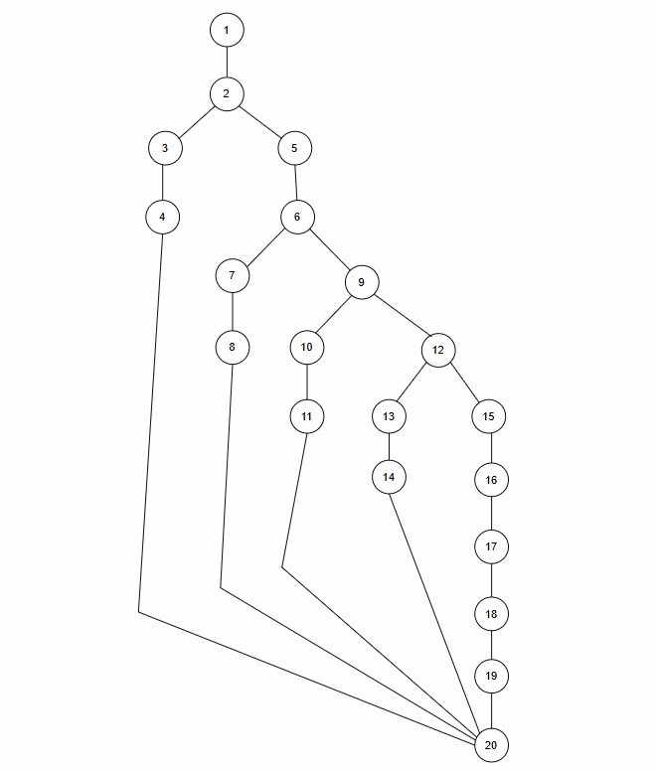

Cyclomatic Complexity:

- Cyclomatic Complexity in Software Testing is a testing metric used for measuring the complexity of a software program.
- Cyclomatic complexity can be calculated by using control flow graphs or with respect to functions, modules, methods or classes within a software program.
➢ Complexity is computed in one of three ways:

Method 1: Using Number of inner Regions + Outer region
Total Regions = 4+1
Cyclomatic Complexity = 5
Method 2:Using Edges and Nodes
V(G)=E−N+2
Here Edges =23 , Nodes = 20
V(G) = 23 – 20 + 2 V(G) = 5
Method 3:Using Decision (Predicate) Nodes
V(G) = P+1
V(G)= 4+1 =5 , Where P = Number of predicate (decision) nodes

3. Independent Program Paths

Path 1 – Consent Not Found 1 → 2 → 3 → 20
Path 2 – Consent Not Active
1 → 2 → 5 → 6 → 7 → 20
Path 3 – Withdrawal Not Initiated by User
1 → 2 → 5 → 6 → 9 → 20
Path 4 – Legal Exception
1 → 2 → 5 → 6 → 9 → 10 → 20
Path 5 – Successful Withdrawal
1 → 2 → 5 → 6 → 9 → 10 → 11 → 20

Design Test Cases:
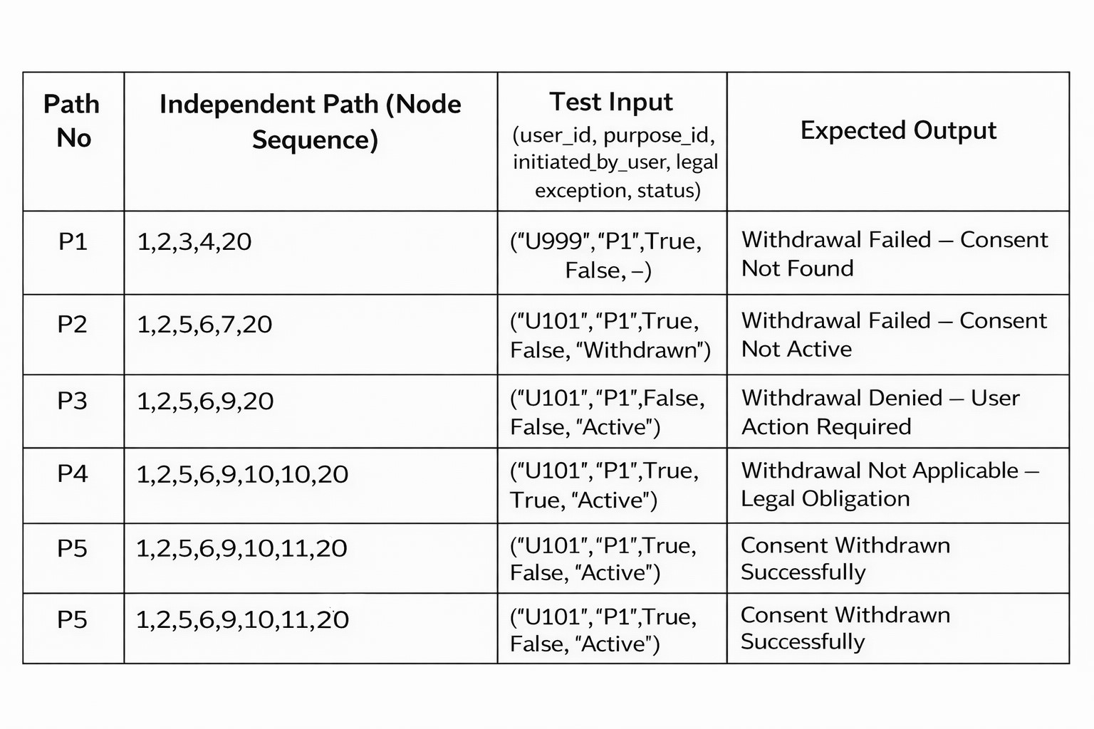
UnitTest:
importunittestconsent_db = {
"U101": {
"P1": {"status": "Active"}
}
}
def consent_withdrawal(user_id, purpose_id, initiated_by_user, legal_exception=False): if user_id not in consent_db or purpose_id not in consent_db[user_id]: return "Withdrawal Failed – Consent Not Found" consent = consent_db[user_id][purpose_id] if consent["status"] != "Active": return "Withdrawal Failed – Consent Not Active" if not initiated_by_user: return "Withdrawal Denied – User Action Required" if legal_exception: return "Withdrawal Not Applicable – Legal Obligation" consent["status"] = "Withdrawn" return "Consent Withdrawn Successfully" class TestConsentWithdrawal(unittest.TestCase): def setUp(self): consent_db["U101"]["P1"]["status"] = "Active" def test_consent_not_found(self): result = consent_withdrawal("U999", "P1", True) self.assertEqual(result, "Withdrawal Failed – Consent Not Found") def test_consent_not_active(self): consent_db["U101"]["P1"]["status"] = "Withdrawn"
result = consent_withdrawal("U101", "P1", True) self.assertEqual(result, "Withdrawal Failed – Consent Not Active") def test_user_not_initiated(self): result = consent_withdrawal("U101", "P1", False) self.assertEqual(result, "Withdrawal Denied – User Action Required") def test_legal_exception(self): result = consent_withdrawal("U101", "P1", True, True) self.assertEqual(result, "Withdrawal Not Applicable – Legal Obligation") def test_successful_withdrawal(self): result = consent_withdrawal("U101", "P1", True) self.assertEqual(result, "Consent Withdrawn Successfully") if __name__ == "__main__": unittest.main()
Output:
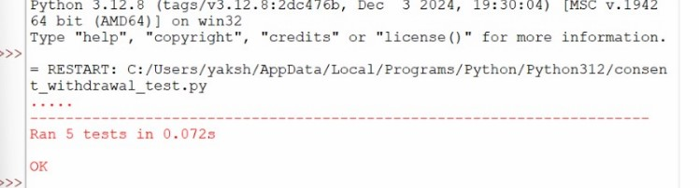

6.2 BlackBox Testing:
Functional Requirements:
The withdrawal module works like this:
- User requests withdraw consent
- System checks if consent exists
- If not → Withdrawal Failed – Consent Not Found
- If consent exists → check status
- If status ≠ Active → Withdrawal Failed – Consent Not Active
- If request not initiated by user → Withdrawal Denied
- If legal obligation exists → Withdrawal Not Allowed
- Otherwise → Consent Withdrawn Successfully
Equivalence Partitioning
- Consent Existence

Class | Condition | Valid/Invalid
EC1 | Consent not found | Invalid
EC2 | Consent found | Valid

- Consent Status
EC3-Active
EC4-Withdrawn
EC5-Expired

Withdrawal Conditions:
EC6-Initiated by User, EC7-Not initiated by user, EC8-Legal Obligation, EC9-No legal obligation

Boundary Conditions:
Critical decision boundaries:
- Consent existence boundary
- Active vs inactive status
- User initiated vs system initiated
- Legal obligation true vs false

7. Conclusion:
- The Digital Consent Management System(DCMS) provides a secure and efficient way to manage user consent for personal data usage. It replaces manual consent methods with a digital system where users can easily give, update, renew, validate, and withdraw consent.
- The system includes modules such as Consent Collection, Consent Validation, Consent Update, Consent Renewal, and Consent Withdrawal, ensuring that personal data is processed only when valid consent is available. Various diagrams like UML,ER, and DFD help explain the system structure and workflow clearly.
- The system also focuses on security, reliability, and performance to protect user data. Testing methods such as White-Box Testing and Black-Box Testing were used to verify the correctness of the modules. Overall, DCMS improves privacy, transparency, and trust between users and organisations.
8. References:
➢ Business Requirement Document For Consent Management Under the DPDP Act, 2023 ➢ Government of India. Digital Personal Data Protection Act, 2023.
9. Acknowledgements:
➢ I would like to express my sincere gratitude to our faculty for his valuable guidance, support, and encouragement throughout the development of this project on Digital Consent Management System. His suggestions and insights helped me successfully complete this project.

DESIGNING PHASE

Component Level Design:
- The Component Level Design of the Digital Consent Management System (DCMS) describes how system is divided into different software components and how these components interact to manage user consent securely.
- The main components of system include User Interface, Authentication service, Consent Controller, Consent Collection, Consent Validation, Consent Update, and database.
- The user interface component allows users to register, login, give consent, update consent, and withdraw consent. It communicates with the Authentication Service to verify user identity.
- The consent Controller acts as central component that manages consent-related operations. It connects with modules such as Consent Collection, Consent Validation, Consent Update to process user consent requests.
- All consent modules interact with database component to store and retrive user information, consent records, and audit logs.
.
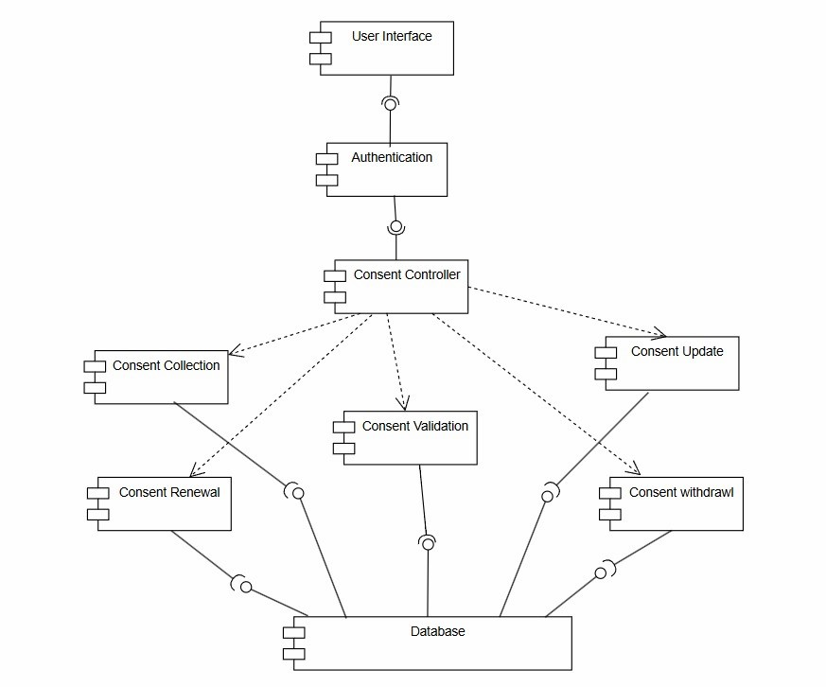

Deployment Level Design:
- This deployment structure helps the system work securely and efficiently.
- The Deployment Level Design of the DCMS shows how the software runs on different hardware devices and how they communicate.
- The system includes User Devices, Web Server, Application Server, Notification Server and Databse Server.
- Users access system from the mobile phone or computer through User Device. The request goes to the Web Server, which sends it to the application server where consent processing and authentication happen.
- The notification server sends alerts and remainders through email or SMS. The database server stores user details , consent records, and audit logs.
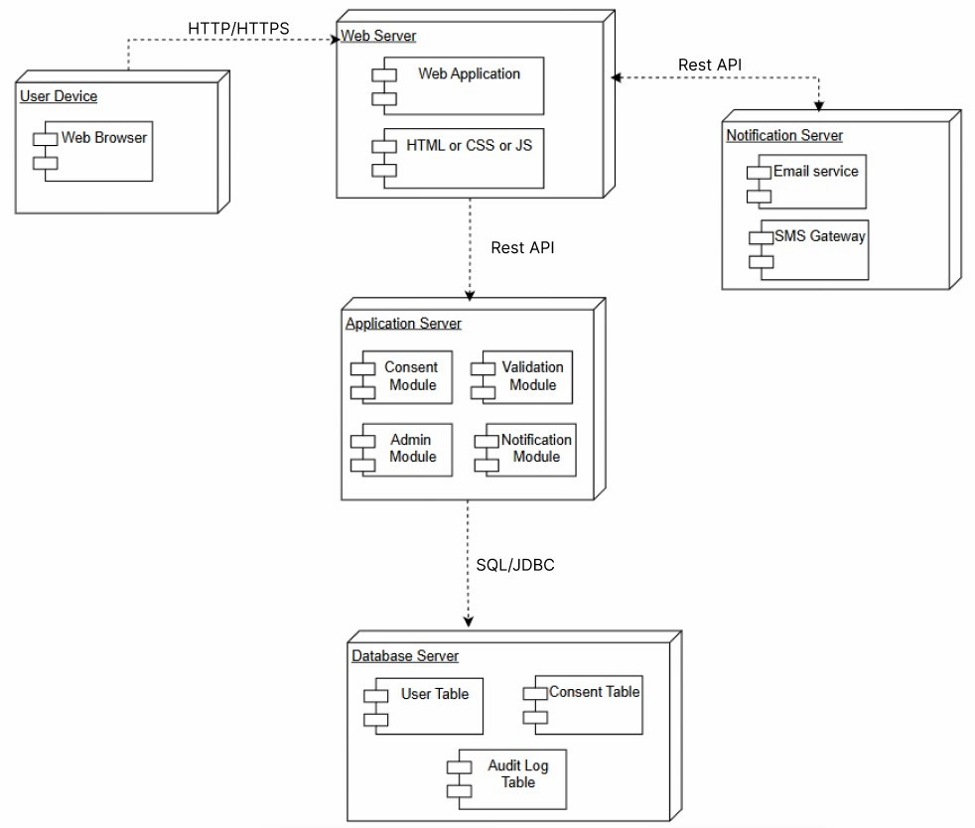

METRICS FOR ANALYSIS MODEL
Apply Function Point Metrics:

Calculate UFP:

Information Domain Value | Count | Weighting Factor | Result
External Inputs(EIs) | 5 | 4 | 20
External Outputs(EOs) | 4 | 5 | 20
External Inquiries(EQs) | 3 | 4 | 12
Internal Logical Files(ILFs) | 3 | 10 | 30
External Interface Files(EIFs) | 2 | 7 | 14
Count Total |  |  | 96
UFP = 20 + 20 + 12 + 30 + 14 UFP = 96
Calculate CAF:
- Does the system require reliable backup and recovery?
- Are specialized data communications required to transfer information to or from the application?
- Are there distributed processing functions?
- Is performance critical?
- Will the system run in an existing, heavily utilized operational environment?
- Does the system require online data entry?
- Does the online data entry require the input transaction to be built over multiple screens or operations?
- Are the ILFs updated online?
- Are the inputs, outputs, files, or inquiries complex?
- Is the internal processing complex?
- Is the code designed to be reusable?
- Are conversion and installation included in the design?
- Is the system designed for multiple installations in different organizations?
- Is the application designed to facilitate change and ease of use by the user?
CAF = 0.65 + ( 0.01 * ∑(Fi ))
∑(Fi ) – the sum of value adjustment factors.
VAF for:
2 factors = 5
6 factors = 4
5 factors = 3
1 factors = 2
∑Fi = 2 * 5 + 6 * 4 + 5 * 3 + 1 * 2
∑Fi = 51
CAF = 0.65 + (0.01 * 51)
CAF = 0.65 + 0.51
CAF = 1.16
Calculate Function points (FP):
UFP VAF/CAF
FP = Total Count + [ 0.65 + (0.01 * ∑(Fi) ] FP = 96 * 1.16

FP = 111.36 FP
Therefore, Function Point(FP) = 111.36 FP.
Assumption:
If 1 FP = 10 hours of development
Total development hours = 111 × 10
= 1110 hours
Number of developers = 4
Working hours per day for each developer = 8 hours
Total team working hours per day = 4 × 8
= 32 hours
Project Duration = 1110 / 32
= 34.68 days
Cost per hour = 500
Estimated project cost = 1110 × 500
= 5,55,000

EmpiricalEstimationModels
COCOMO Model

Basic COCOMO Model:

- The Basic COCOMO can be used for quick and slightly rough calculations of Software Costs.

- The following formulas are used to calculate effort and time estimates.

Effort ( E ) = A*(KLOC)B

Time (T) = C*(Effort)D

Persons required = Effort / Time

- The constant values A, B, C and D for the Basic Model for the different categories of software
projects.

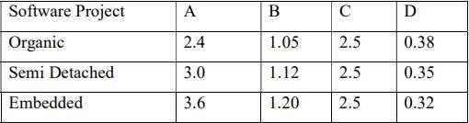

- My project is estimated to have 13KLOC hence comes under Organic Mode.

- Effort ( E ) = A*(KLOC)^B

E = 2.4 * (13)1.05 = 35.469 Person-Months

- Time (T) = C*(Effort)^D

T = 2.5 * (35.469).38 = 9.70 Months

- Persons Required = Effort / Time
P = 34.469 / 9.70 = 4 Persons

Intermediate COCOMO Model:

- In the intermediate COCOMO model, various other factors such as reliability, experience, and Capability are considered along with LOC to estimate effort and time schedule.
(i) Product attributes:
1. Required software reliability extent
2. Size of the application database
3. The complexity of the product

(ii) Hardware attributes:
4. Run-time performance constraints
5. Memory constraints
6. The volatility of the virtual machine environment
7. Required turnabout time
(iii) Personnel attributes:
8. Analyst capability
9. Software engineering capability
10. Applications experience
11. Virtual machine experience
12. Programming language experience

(iv) Project attributes:
13. Use of software tools
14. Application of software engineering methods
15 . Required development schedule
- The Intermediate COCOMO model formulas are:
Effort ( E ) = (A*(KLOC)B ) * EAF.
Time (T) = C*(Effort)D
Persons required = Effort / Time
EAF = Product of cost drivers
The constant values A, B, C and D for the Intermediate Model for the different categories of software projects.
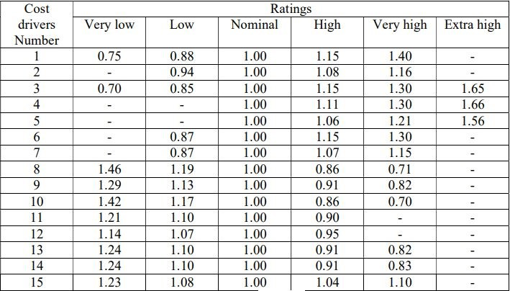
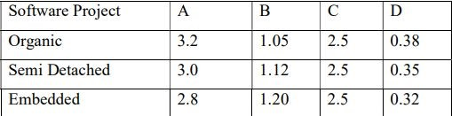

EAF = 1.15 * 1.00 * 1.00 * 1.00 * 1.00 * 1.00 * 1.00 * 0.86 * 1.00 * 1.13 * 1.10 * 1.00 * 0.91 * 1.00 * 1.00

EAF = 1.13

- Effort ( E ) = (A*(KLOC)^B ) * EAF

E = 3.0 * (13)^1.12 * 1.13 = 59.95 Person-Months

- Time (T) = C*(Effort)^D

T = 2.5 * (60)^0.35 = 10.478 Months

- Persons required = Effort / Time

P = 59.95 / 10.478 = 5.78 = 6 Persons

